Electronics Documentation

1. Electronics Block Diagram
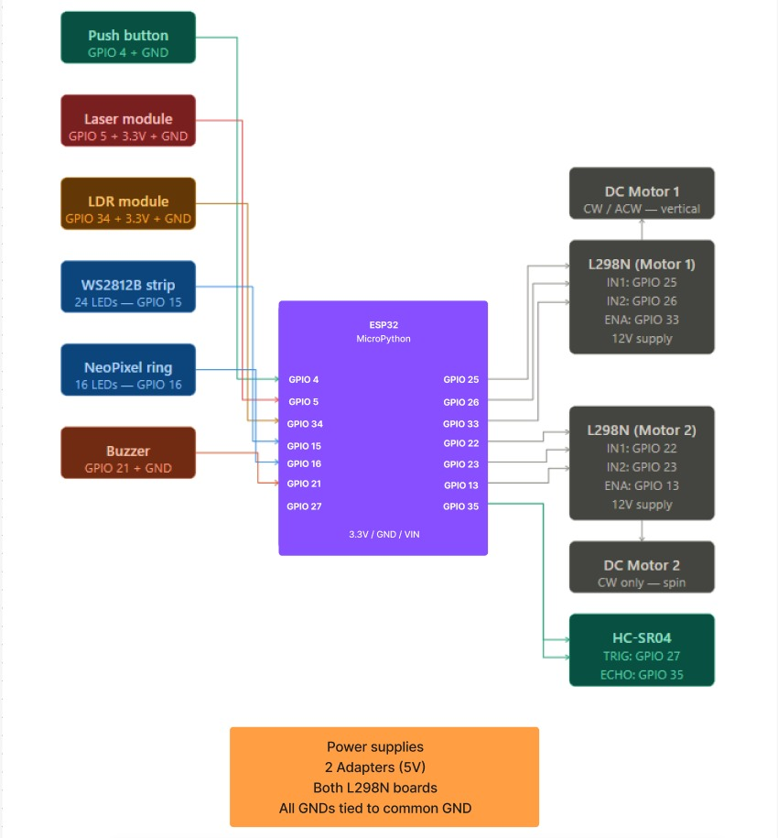

2. Components Table
Component | Quantity | Purpose | Justification
Push Button | 1 | The button turns the laser module on | Enables user-triggered activation, initiating the system sequence.
Laser Module | 1 | To have a dynamic start to the ride using mirrors in the style of a maze | Emits a focused beam suitable for precise path alignment across multiple reflections.
Light Dependent Sensor | 1 | To detect the laser’s light for the maze to complete | Detects successful beam arrival to confirm maze completion and has adjustable sensitivity.
Neopixel | 1 | Blinks to signal the ride is ready to play with. Also for cool light show | Integrates individually addressable LEDs, enabling programmable, high-resolution visual feedback at once
LEDs and Buzzers | Multiple | For signalling systems are ready and for extra effects | Deliver low-power, real-time visual and auditory outputs for clear system state indication.
DC Motor | 1 | To spin the gear of the linear actuator | Supplies continuous rotational motion with sufficient torque for driving mechanical components like linear actuators.
Ultrasonic Sensor | 1 | To detect the hand movement pattern | Utilizes distance measurement to detect and interpret proximity-based hand gestures without physical contact.

